Fault-Tolerant Swarm Quadrotor Control for Non-Convex Geodetic Mapping
Izma Alhazmi Herdian^{1, 2, a)}, Sulthan Naufal Affan^{1, b)}, and Estiyanti Ekawati^{1, 2, c)}
¹Engineering Physics Department, Institut Teknologi Bandung, Bandung 40132, Indonesia
²Center for Instrumentation Technology and Automation, Institut Teknologi Bandung, Bandung 40132, Indonesia
^{a)}Corresponding author: izmaherdian@gmail.com
^{b)}sulthannaufal96@gmail.com ^{c)}esti@itb.ac.id
Abstract. Surveying a non-convex site with a quadrotor swarm must remain safe and complete when the wind is strong, obstacles are unknown in advance, and agents fail in flight. We present a three-layer architecture for this task. The high level partitions the region by polygon-clipped centroidal Voronoi tessellation, plans boundary-following boustrophedon sweeps and reallocates the unswept lanes of failed agents. The mid level maps obstacles with on-board LiDAR and filters every velocity command through a control barrier function quadratic program whose admissible approach-speed function follows from the tilt limit and dead time of the vehicle. The low level is a cascaded PID with gains synthesised from the LQR or the H∞ Riccati equation. Seven quadrotors were flown in ROS 2/Gazebo over one convex and three non-convex regions under Gauss–Markov turbulence (σ = 2.5 m/s) with a recorded mean wind of 3.0 m/s, nine unmapped static and two moving obstacles, and two scheduled agent losses. Seven of eight missions finished with 96.9–99.0% coverage despite losing 28.6% of the fleet. PID-H∞ completed all four regions; in the three regions where both controllers finished, it lowered the RMS lateral sweep error by 16–31%, mostly by rejecting the mean wind, and finished 11–15% sooner, at 3.9–5.6 times the torque effort of PID-LQR. One PID-LQR mission was stopped after an agent struck an obstacle, and in three other missions an agent passed within rotor reach of a cylinder. Each configuration was flown once, so these are single-run observations.

Introduction
Multi-rotor swarms shorten aerial surveys, but real sites are rarely rectangles: they have re-entrant corners, gusty wind, obstacles unknown before take-off, and vehicles that fail. Centroidal Voronoi tessellation (CVT) with Lloyd’s iteration [1] distributes agents over a region and has been combined with obstacles and actuator faults [2], safety constraints [3], non-convex domains [4] and agent dropout [5]; boustrophedon sweeps remain a standard way to cover a cell [6, 7], including cooperative UAV surveys [8] with re-planning after failures [9]. Control barrier functions (CBF) enforce safety as a quadratic program (QP) on the input [10, 11], with high-order [12], multi-robot [13] and quadrotor forms for moving obstacles [14] and wind gusts [15]; LQR and H∞ synthesis [16] remain common for multirotor control under wind [17], and swarm fault tolerance is an active topic [18]. Hierarchical quadcopter swarms with a reactive potential-field planner above cascaded PID loops fly formations through clutter and gusts, yet purely reactive planners remain prone to U-shaped traps [19].
What is less reported is how these pieces behave together on a physically simulated vehicle, where velocity commands are not realised instantly and wind drift costs coverage. This paper contributes (i) an architecture running polygon-aware CVT partitioning, boundary-following sweeps and lane-level fault reallocation above a LiDAR-mapped CBF-QP whose admissible approach speed is derived from the closed-loop model of the vehicle; (ii) a comparison of PID gains from the LQR and H∞ Riccati equations, on the linear model and inside the swarm; and (iii) an evaluation of eight missions under combined hazards, including their failures.

Methodology

System Architecture
Figure 1 shows the three layers, defined per agent: a cell, a lane queue, a safety filter using neighbours within 6 m and obstacles within 10 m, and a flight controller. The upper layers of all agents run in one 20 Hz ROS 2 node [20], sharing the coverage grid, obstacle map and failure notices without delay, and each vehicle runs its own 250 Hz low level; distributing the upper layers is future work.
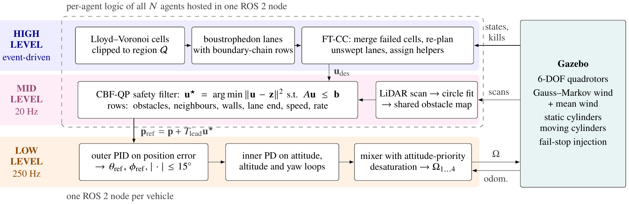
FIGURE 1. Three-layer architecture: per-agent layers, with the high and mid levels of all agents hosted in one ROS 2 node and one low-level controller per vehicle.
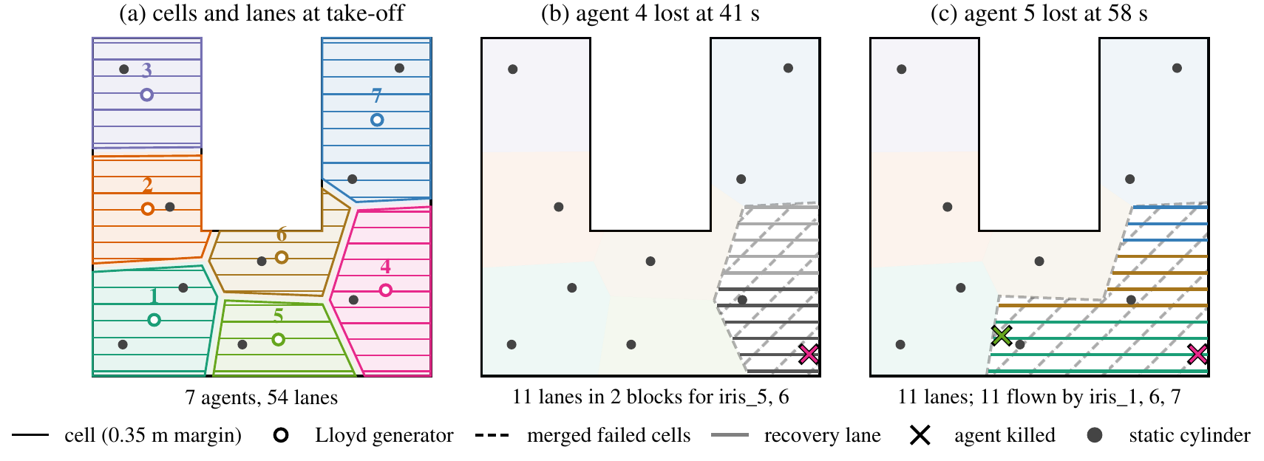
FIGURE 2. High-level planning in the PID-H∞ U-shape mission, reproduced with the planner code (centroids within 0.6 cm of the log, identical lane counts). (a) Cells and their 54 lanes; first and last lanes follow the cell boundary. (b) Agent 4 is lost; its cell yields 11 lanes for agents 5, 6. (c) Helper 5 is lost too; the merged cells yield 11 lanes, coloured by the agent that flew them.

High Level: Partition, Sweep and Fault-Tolerant Cooperative Coverage
Given the region polygon 𝒬 and generators g_{i}, the cell of agent i is
 | $$P_{i}=\{q∈Q:‖q-g_{i}‖≤‖q-g_{j}‖, ∀j≠i\},$$ | (1)
computed by clipping bisector half-planes and intersecting the result with 𝒬. Lloyd’s iteration g_{i} ← centroid(𝒫_{i}) (25 iterations from deterministic k-means++ seeds) minimises $\sum_{i}{\int_{P_{i}}{‖q-}}g_{i}‖^{2}dq$ [1], and agents are assigned to cells by the Hungarian algorithm. Each cell is shrunk by 0.35 m and swept by east–west lanes at most 1.45 m apart; its first and last lanes follow the cell boundary, so the wedges that a fixed-pitch sweep leaves at slanted Voronoi edges are flown too (Fig. 2a). With a sensing radius r_{s} = 0.95 m the swath is 1.90 m (overlap of at least 0.45 m). Coverage is scored on a 0.30 m grid: a grid cell inside 𝒬 counts once its centre has been within r_{s} of a live, sweeping agent flying above 0.8 m; grid cells under static obstacles are excluded.
When agent k fails, Fault-Tolerant Cooperative Coverage (FT-CC) keeps the recovery lanes that k still carried, erases the coverage recorded inside 𝒫_{k} (the data of the lost vehicle are treated as lost), merges all failed cells, re-plans lanes over their union and drops lanes that are already at least 80% covered. The helpers are the neighbours of the failed cells closest to the recovery centroid (one for a single loss with at most five lanes, otherwise two, and three after a second loss). They receive contiguous serpentine blocks, which they fly at once if their own cell is finished and append to their queue otherwise (Fig. 2b,c).

Mid Level: Obstacle Mapping and CBF-QP Safety Filter
Obstacle map. Each 360-ray scan is cleaned of returns within 0.55 m of other agents and 0.80 m of the arena boundary, clustered, and fitted with circles; detections form one swarm-wide track list, a track is confirmed after 12 hits and rejected if it moves, and only confirmed tracks enter the QP, so the swarm starts with an empty map. The planner deliberately ignores obstacles, leaving avoidance to the safety filter. The two moving obstacles are taken from simulator odometry, i.e. assumed perfectly tracked.
Actuator-consistent barrier. With the reference rule p_{ref} = p + T_{lead}u, the outer PID makes the commanded-velocity response first order with an acceleration limit, $\overset{˙}{v}={sat}_{±a_{max}}(k_{v}(u-v))$, where
 | $$k_{v}=gK_{d}, a_{max}=gtanθ_{max}, T_{lead}=\frac{K_{d}-k_{ff}}{K_{p}}, v_{c}=\frac{a_{max}}{k_{v}},$$ | (2)
with θ_{max} = 0.262 rad (15°) and k_{ff} = 0.15 rad s/m. With the LQR outer-loop gains (used for both controllers) k_{v} = 3.867 s⁻¹, a_{max} = 2.631 m/s², T_{lead} = 0.323 s and v_{c} = 0.680 m/s. The stopping distance from speed s > v_{c} is D(s) = (s² + v_{c}²)/2a; requiring that the distance travelled during a lumped dead time T_{d} = 0.40 s plus D(s) fit inside the clearance h gives the admissible approach speed
 | $$φ(h)=\left\{\begin{matrix}max(0,-aT_{d}+\sqrt{max(0,a^{2}T_{d}^{2}+2ah-v_{c}^{2})}), & h≥0, \\ γ_{r}h, & h<0,\end{matrix}\right.$$ | (3)
which is exactly zero for h ≤ v_{c}²/2a, unlike a linear γh (Fig. 3a). It is continuous and non-decreasing with φ(0) = 0, but because of this flat segment it is not strictly increasing and hence not a class-𝒦 function in the strict sense; the branch h < 0 (γ_{r} = 3.5 s⁻¹) demands an outward velocity once the set has been left. The budget is a = max(0.15a_{max}, μa_{max} − |a_{obs}| − |a_{wind}|) with μ = 0.75 (0.85 for walls) and a wind allowance of 0.5 m/s².
Quadratic program. For an obstacle or neighbour at o with n̂ = (p − o)/‖p − o‖, the condition ḣ ≥ −φ(h) is the linear row
 | $$-{\hat{n}}^{⊤}u≤λφ(h)-{\hat{n}}^{⊤}v_{o}, h=‖p-o‖-(ρ+r_{d}+δ),$$ | (4)
with drone radius r_{d} = 0.22 m, obstacle radius ρ (fitted radius +0.05 m for mapped cylinders, 0.50 m for moving ones), margins δ = 0.35 m (static) and 0.75 m (moving), and λ = 1 for obstacles. Neighbour rows are reciprocal (λ_{ij} + λ_{ji} = 1, weighted by mission state) at a hard radius of 0.70 m and a soft radius of 1.20 m; walls and the end of the current lane give half-plane rows, and inscribed polygons bound the speed (3 m/s) and the per-tick change of u. Each agent then solves
 | $$u^{⋆}=\underset{u∈R^{2}}{argmin}‖u-z‖^{2}\text{ s.t. }Au≤b, z=\frac{u_{des}+t+wu_{prev}}{1+w},$$ | (5)
exactly, by enumerating the unconstrained point, the projections onto every row and the pairwise vertices (Fig. 3b). A tangential bias t, applied within a 60° cone of a head-on approach, breaks symmetric deadlocks and enters only the objective; w = 0.25 smooths successive commands. If the QP is infeasible, soft rows are released (tier 1), then the violation of the hard rows is minimised (tier 2), and a scaled previous command is the last resort (tier 3).

Low Level: LQR and H∞ Gain Synthesis
Each axis is modelled about hover as a double integrator ẋ = Ax + Bu (e.g. B = [0, g]⊤ from pitch to x, B = [0, 1/I_{y}]⊤ from torque to pitch) and augmented with an integrator on the input, x_{a} = [x⊤,u]⊤. The LQR design solves the algebraic Riccati equation (ARE) for K_{a} = R⁻¹B_{a}⊤P. The H∞ design treats a disturbance entering through the input channel, B_{w} = [B⊤,0]⊤, and solves
 | $$A_{a}^{⊤}P+PA_{a}+Q_{a}-P(B_{a}R^{-1}B_{a}^{⊤}-γ^{-2}B_{w}B_{w}^{⊤})P=0,$$ | (6)
rejecting solutions for which A_{a} − B_{a}K_{a} is not Hurwitz [16], with γ = 1.3 γ_{min} and γ_{min} found by bisection. The state-feedback gain is mapped to PID form through the pseudo-inverse of Γ = [C⊤,(CA)⊤,(CA²)⊤; 0,(CB)⊤,(CAB)⊤]; the synthesised inner integral gain is not used. Figure 4 shows where the gains enter the signal path of one control step, and Table 1 lists weights, attenuation levels and gains.
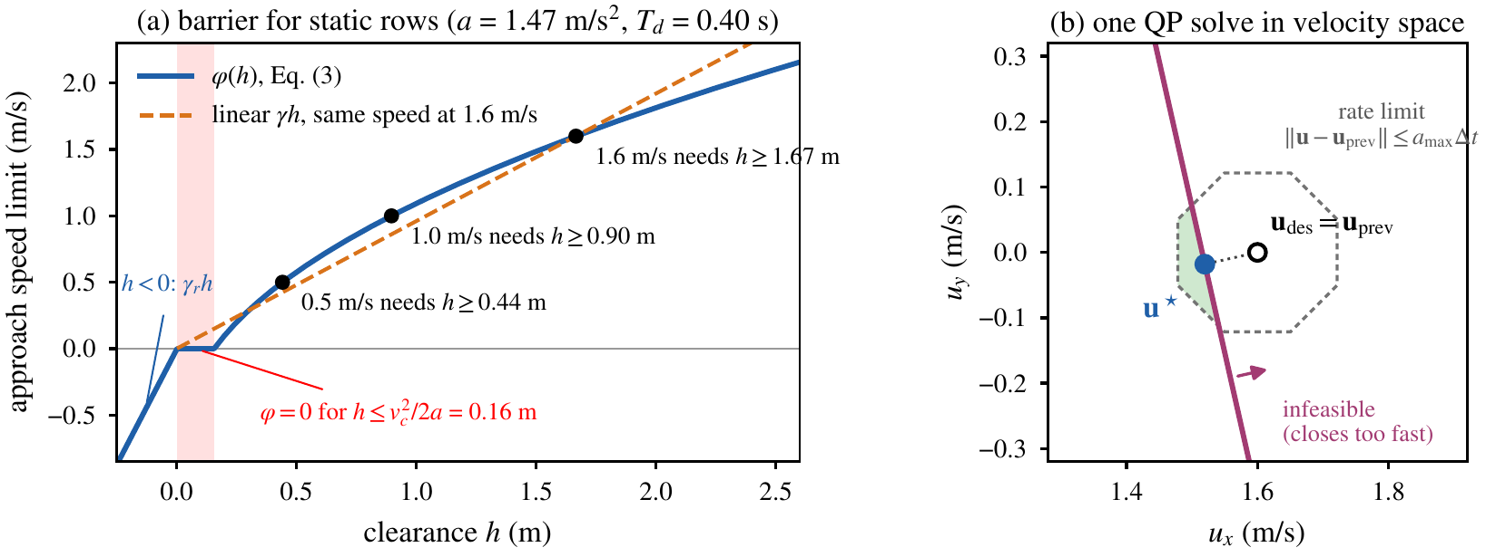
FIGURE 3. Mid-level safety filter with mission parameters. (a) φ(h) of Eq. (3) for static rows: zero below h = 0.16 m, h ≥ 1.67 m needed at 1.6 m/s; a linear γh permits approach where φ demands a stop. (b) One QP solve by the flight code for an illustrative case (cylinder 2.51 m ahead): the closing speed drops from 1.56 to 1.48 m/s.
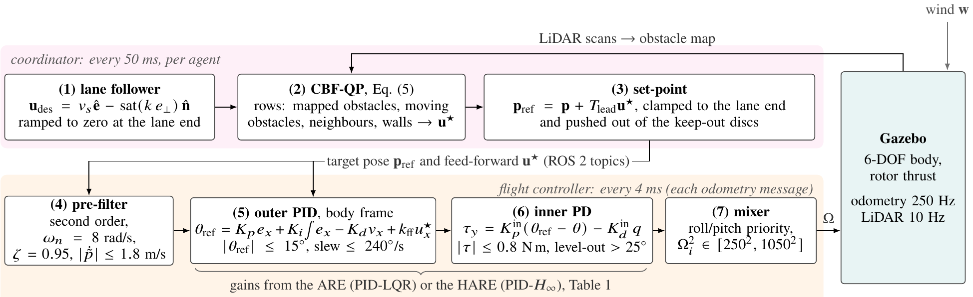
FIGURE 4. Signal path of one control step. The coordinator (1)–(3) publishes a set-point and a velocity feed-forward every 50 ms; the flight controller (4)–(7) runs on each 4 ms odometry message. The controllers differ only in the gains of (5)–(6) and in the position integrator (PID-H∞: always active, clipped to ±0.6; PID-LQR: active within 0.25 m, clipped to ±0.4).
TABLE 1. Gain synthesis (outer x/y and inner roll/pitch loops) and linear analysis of the outer loop with the inner loop closed. ‖G‖∞: peak gain from a disturbance acceleration to position; PM/GM: outer-loop phase and gain margins (implemented inner PD gains).
Design | Loop | Q, R | γ_{min} → γ | K_{p} | K_{i} | K_{d} | ‖G‖∞ (s²) | PM | GM
PID-LQR | outer | diag(0.08, 0.35), 1 | – | 0.757 | 0.283 | 0.394 | 0.158 | 37.4° | 11.5 dB
PID-LQR | inner | diag(6, 0.6), 0.05 | – | 4.868 | – | 0.534 | 0.158 | 37.4° | 11.5 dB
PID-H∞ | outer | diag(0.10, 0.40), 1 | 2.54→3.30 | 2.705 | 1.092 | 1.107 | 0.040 | 25.2° | 9.0 dB
PID-H∞ | inner | diag(4, 0.4), 0.06 | 2.54→3.31 | 11.604 | – | 1.189 | 0.040 | 25.2° | 9.0 dB

Simulation Setup
Seven 3DR Iris quadrotors (m = 1.50 kg, I_{xx} = I_{yy} = 0.0291, I_{zz} = 0.0552 kg m², arm 0.22 m, k_{f} = 8.549×10⁻⁶ N s², rotor speed ≤ 1100 rad/s) are simulated in Gazebo [21] with ROS 2. Controllers read ground-truth odometry; no state estimator is in the loop. Missions start from a launch pad south of the region, cruise at 2.0 m and sweep at 1.6 m/s. Four regions inside a 28×28 m box are used (Fig. 5): rect (784 m²), L-shape (588 m²), U-shape (624 m², 10 m wide notch) and plus (460 m², 10 m wide arms), each with nine vertical cylinders (r = 0.40 m, 4 m tall) placed inside the region. All missions use the same combined-hazard scheme:
- Wind. A first-order Gauss–Markov process per horizontal axis (σ = 2.5 m/s, correlation time 0.5 s, seed 42), a surrogate for the Dryden and von Kármán models used in quadrotor studies [22], plus a constant −2 m/s mean on each axis (2.8 m/s horizontally) from t = 5 s, uniform in space and applied through the Gazebo wind-effects plugin (vertical component scaled by 0.4). Recorded mean (−2.34,−1.95) m/s, standard deviation (2.45,2.51) m/s, horizontal peaks 12.0 m/s.
- Moving obstacles. Two kinematic cylinders (r = 0.45 m) oscillate along the region diagonals with amplitude 10 m on each axis (12 m, offset by 1 m, in plus) at 0.15 and 0.11 rad/s, i.e. peak speeds along the diagonal of 1.6–2.5 m/s.
- Agent loss. When coverage first reaches 18% and 32%, one pre-selected agent is killed (rotor speeds set to zero, fail-stop) and the coordinator is notified at once. Victims were chosen to own comparable cells next to the launch pad (Table 2); in rect the first victim differed (4 vs. 7), so that pair is not like-for-like.
TABLE 2. Mission results. T: mission time; lat.: RMS lateral sweep error; v̄: mean sweep speed; alt.: RMS altitude error; tilt: 95th percentile while sweeping, and maximum; effort: mean τ_{x}² + τ_{y}² (N²m²); d_{obs}, d_{v2v}: minimum surface distance to a static cylinder and inter-agent distance; tier: solves needing tier 1–2. Killed: rect 4, 7 (H∞), 7 (LQR); L 4, 7; U 4, 5; plus 1, 7. The plus missions use three extra transit guards.
Region | Controller | Status | Cov. (%) | T (s) | lat. (cm) | v̄ (m/s) | alt. (cm) | tilt₉₅ (°) | tilt_{max} (°) | effort | d_{obs} (m) | d_{v2v} (m) | tier (%)
rect | PID-H∞ | done | 98.2 | 260 | 7.2 | 1.20 | 2.5 | 14.7 | 21.1 | 0.054 | 0.49 | 1.71 | 2.9
rect | PID-LQR | abort@78.8 s | n/a | n/a | 11.7 | 1.12 | 7.3 | 14.7 | 155.9 | 0.024 | 0.06 | 1.52 | n/a
L-shape | PID-H∞ | done | 98.4 | 204 | 8.4 | 1.19 | 2.5 | 14.5 | 20.8 | 0.058 | 0.57 | 1.32 | 3.8
L-shape | PID-LQR | done | 98.5 | 236 | 12.2 | 1.11 | 2.6 | 14.5 | 26.3 | 0.010 | 0.29 | 0.79 | 4.2
U-shape | PID-H∞ | done | 98.5 | 205 | 8.3 | 1.21 | 2.6 | 14.8 | 20.7 | 0.044 | 0.63 | 1.77 | 4.1
U-shape | PID-LQR | done | 96.9 | 240 | 11.4 | 1.07 | 2.5 | 14.2 | 16.6 | 0.011 | 0.42 | 1.73 | 4.1
plus | PID-H∞ | done | 98.4 | 198 | 9.7 | 1.15 | 5.4 | 14.7 | 82.5 | 0.053 | 0.24 | 1.24 | 4.1
plus | PID-LQR | done | 99.0 | 222 | 11.5 | 1.02 | 2.6 | 14.4 | 40.1 | 0.014 | 0.24 | 1.12 | 4.9

Both controllers share the planner, filter and plant model (Eq. (2) with LQR gains). Each region–controller pair was flown once (N = 1) and recorded on video; the two plus missions also include three transit guards (stall detector, speed reduction above 16° tilt, 20 s start-wait timeout). A mission is complete when every surviving agent has finished its lanes and returned to its cell centroid; a run is stopped if an agent that is not a scheduled victim drops below 0.5 m. Metrics use the 20 Hz controller logs without the first 20 s and without rows after a kill. Lateral error is taken during steady east–west sweeps (heading stable for 1.5 s, speed above 0.6 m/s), torque effort is the mean of τ_{x}² + τ_{y}², and obstacle distance is measured from the drone centre to the cylinder surface; the airframe reaches 0.235 m (body) to 0.348 m (rotor tips), so smaller distances mean certain or possible contact. We also assume a lightweight rotor guard, as on collision-tolerant multirotors [23], so that grazing contacts load the guard rather than the propellers; the guard is not simulated and changes no reported number.
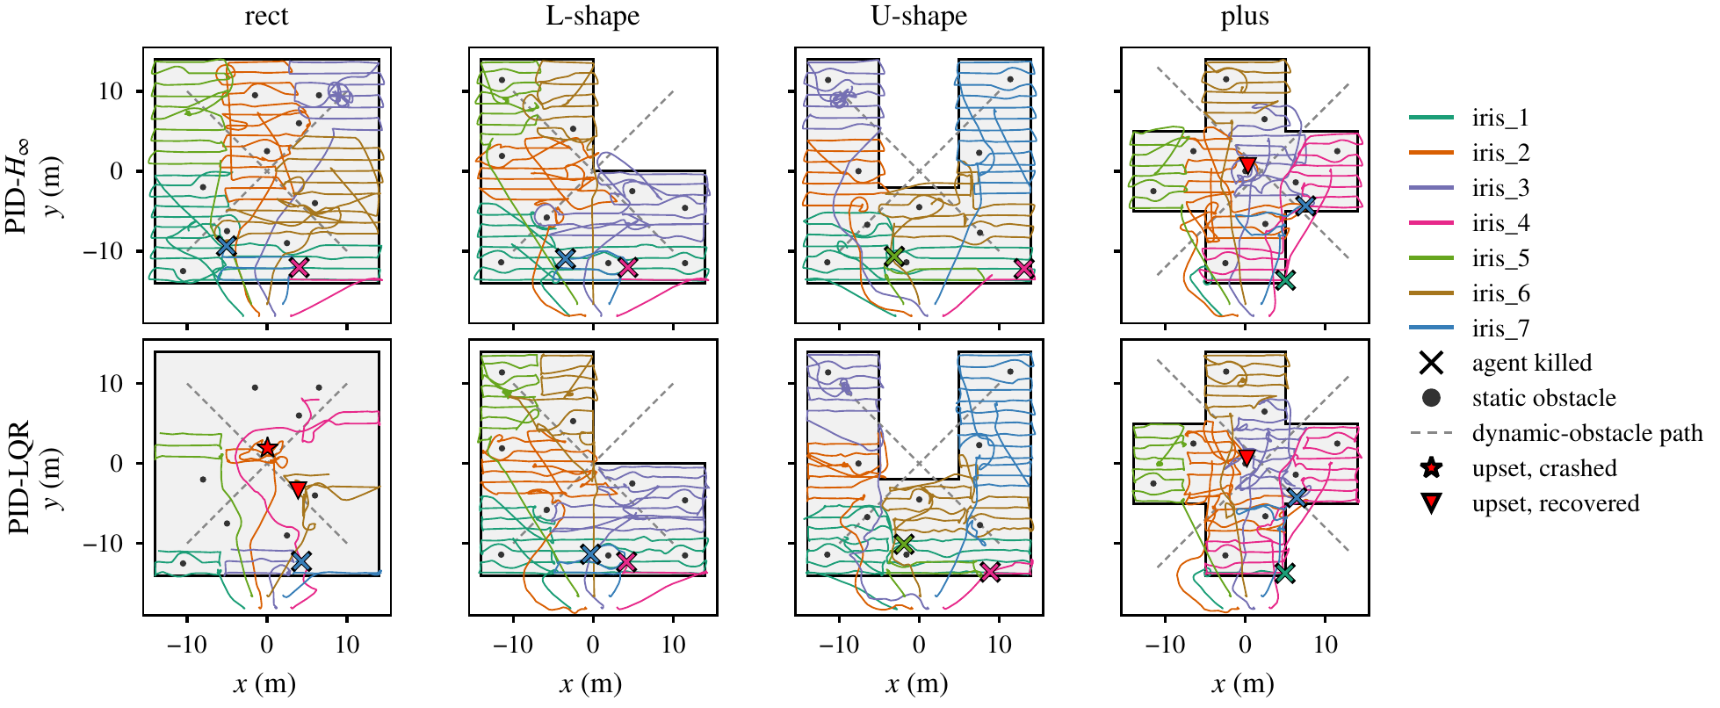
FIGURE 5. Flown trajectories of live agents above 0.5 m, including transit from the launch pad (y ≈ − 18 m).

Results and Discussion

Mission Completion and Fault Recovery
Table 2 and Fig. 5 summarise the eight missions. Seven finished with all survivors back at their cell centroids and 96.9–99.0% coverage, despite losing two of seven agents at 18% and 32% coverage. Every obstacle map held all nine cylinders (centre and radius within the 0.1 m log resolution) plus at most two unmatched tracks, and no completed mission needed tier 3. Each kill causes a small drop, as the failed cell’s coverage is erased, before the slope resumes (Fig. 6); Fig. 7 shows the final maps. The PID-LQR U-shape mission completed at 96.9%, below the 97% reference level of Fig. 6, with thin uncovered strips along cell boundaries in the left arm, nearly absent for PID-H∞; their cause was not isolated. The PID-LQR rect mission was stopped at 78.8 s after an unscheduled crash (see Safety).
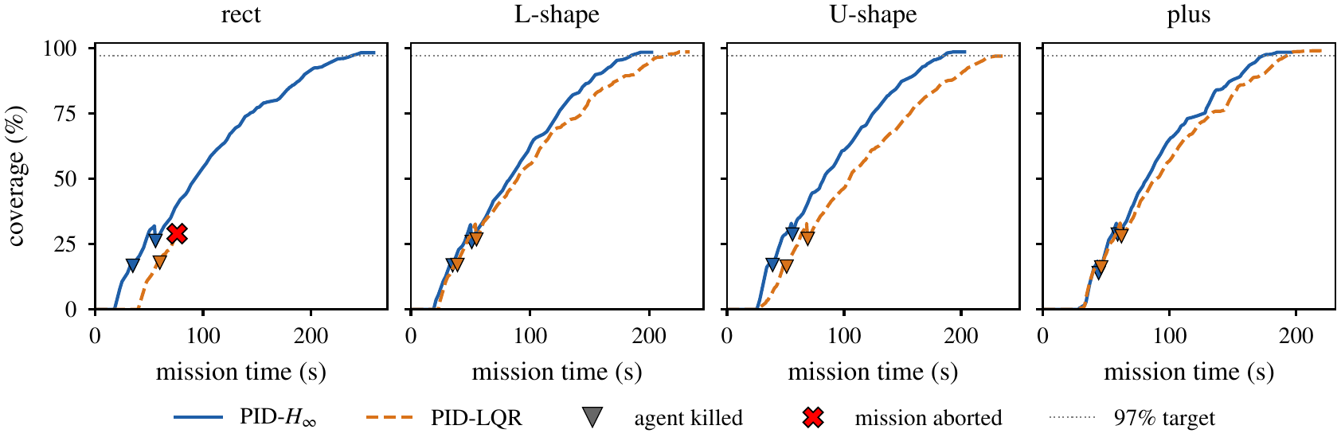
FIGURE 6. Coverage against mission time (coordinator clock). Triangles: agent kills, after which the failed cell is re-swept; dotted: 97% reference level (completion is defined by the survivors finishing their lanes).
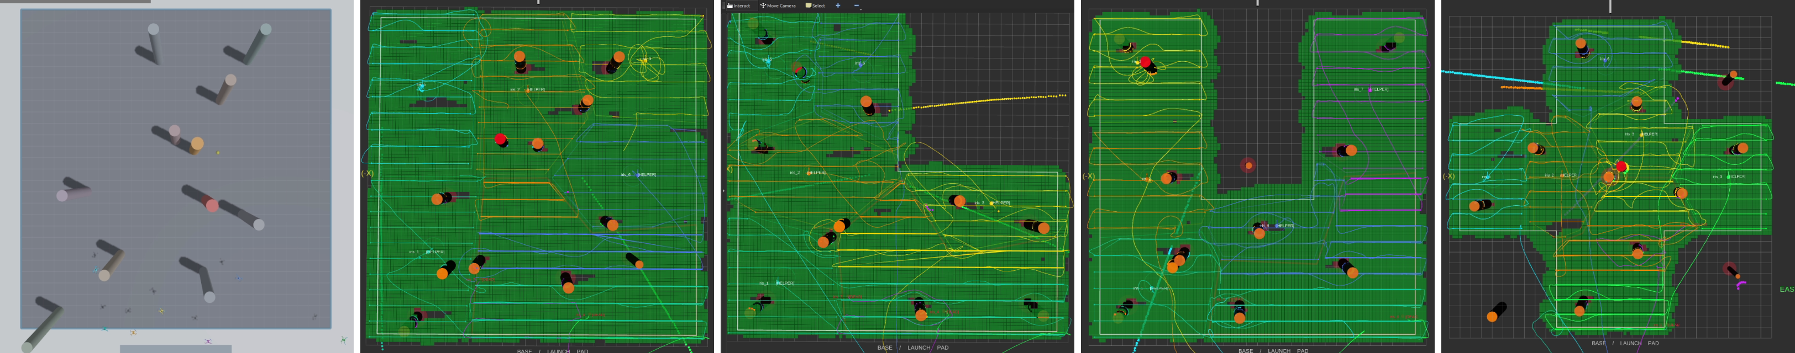
FIGURE 7. (a) Gazebo, rect scenario (screenshot); (b)–(e) final RViz coverage maps (green) of the PID-H∞ missions, from the recordings.

Tracking under Turbulence: LQR versus H∞ Gains
The two designs differ clearly in how tightly they hold a lane (Fig. 8a): the median lateral error was 2.7–3.8 cm with PID-H∞ and 8.5–8.8 cm with PID-LQR, and the RMS error fell from 11.4–12.2 cm to 7.2–9.7 cm in all four regions (16–31% where both finished; 39% in the truncated rect pair). Most of the difference is a mean offset: PID-LQR flew −5.7 to −7.0 cm downwind (towards −y), PID-H∞ within 0.7–1.6 cm of the lane, with closer standard deviations (7.0–9.6 vs 9.4–10.8 cm). The H∞ outer integral gain is 3.9 times larger, and the PID-LQR node freezes its position integrator when the error to its set-point exceeds 0.25 m on either axis; since the set-point leads the vehicle along the lane by T_{lead}u★ ≈ 0.4 m, this happened in 36–45% of its sweep samples. Mean sweep speeds of 1.15–1.21 against 1.02–1.12 m/s (command 1.6 m/s) contribute to the 11–15% shorter missions; the 95th-percentile tilt was essentially equal, as was altitude error outside the two missions with upsets. In the linear analysis (Table 1) the H∞ gains lower the worst-case disturbance-to-position gain by 4.0 times and the position deviation under the Gauss–Markov input by 3.7 times (Fig. 8c).
The price is a higher effort: in the three completed pairs PID-H∞ used 3.9–5.6 times the torque effort of PID-LQR (Fig. 8b), with motor saturation below 0.2% of samples, and its outer loop has a higher crossover (9.08 vs 4.09 rad/s) and smaller margins. The measured reduction is far below the linear factor because tilt limit, pre-filter, QP rate limits and wind force model are not in the linear model. As Q, R differ and the integrator gating belongs to the PID-LQR node, this compares two complete gain designs and does not isolate the effect of γ from that of higher loop gain.

Safety: Clearance, Contact and Upset Events
No two agents came closer than 0.79 m (PID-LQR, L-shape), above the 0.70 m hard radius. The minimum surface distance to static cylinders was 0.49, 0.57 and 0.63 m under PID-H∞ and 0.06, 0.29 and 0.42 m under PID-LQR in rect, L- and U-shape, the PID-LQR rect and L-shape values meaning body and possible rotor contact; in plus both passed within 0.24 m of the central cylinder, also inside the rotor envelope, where the assumed guard takes the contact. The upsets (Fig. 9) share a pattern: each happened while the agent stepped to its next lane beside a cylinder, after 1–4 s of tier-2 solves bound by that cylinder. In the PID-LQR rect mission agent 2 came within 0.06 m of the cylinder at (0,2.5) (body contact), tilted to 155.9° and fell; by protocol the run was then stopped, so this crash was scored as a failed mission rather than handed to FT-CC. In plus, agent 2 of both missions grazed the central cylinder, tilting to 40.1° (PID-LQR) and 82.5° (PID-H∞, dropping to 0.64 m and recovering within about 3 s). With one run per case these events cannot be attributed to the controller; plausible contributors are obstacle-blind lanes ending inside a cylinder’s margin, a barrier built on a 0.22 m disc, and a fixed 0.5 m/s² wind allowance that ignores gusts of up to 12.0 m/s. A 50.8° upset (PID-LQR, rect, agent 6, 24.4 s) before sweeping, 0.55 m from the nearest cylinder, was recovered.
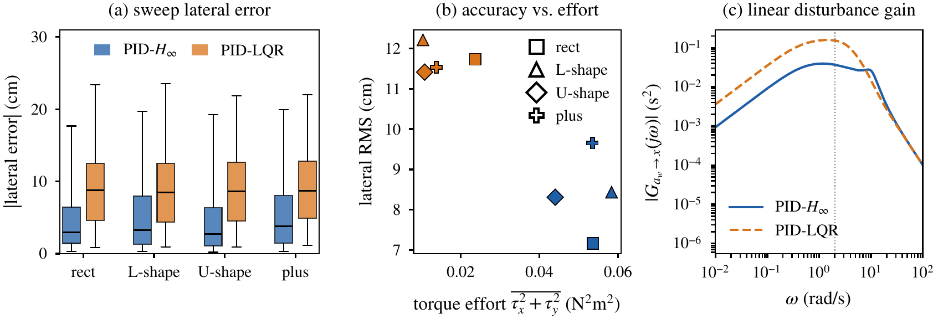
FIGURE 8. (a) Absolute lateral error in steady east–west sweeps (box: quartiles, whiskers: 5th–95th percentiles). (b) RMS lateral error against torque effort. (c) Disturbance-to-position gain of the linearised outer loop; dotted: wind-model corner frequency.
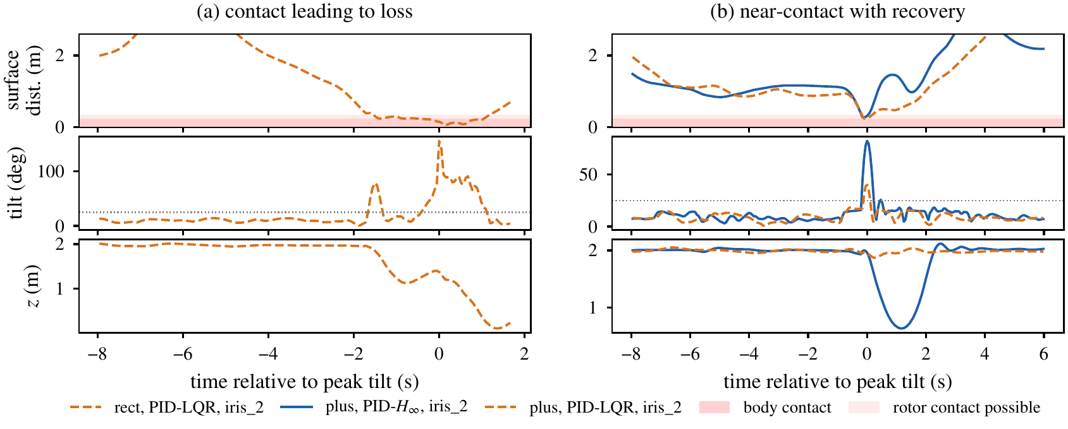
FIGURE 9. Upsets aligned at peak tilt: surface distance to the nearest static cylinder (dark: body contact; light: rotor contact possible), tilt (dotted: 25° level-out) and altitude. (a) PID-LQR, rect, agent 2: contact and loss. (b) plus, agent 2, both controllers: graze and recovery.
In all 8 missions some tier-2 solves bound by a moving-obstacle row reported a negative minimum barrier value (down to −0.68 m): the log keeps only the minimum over all rows and no moving-cylinder positions, so contact can be neither confirmed nor excluded; from a moving-obstacle row, that value would mean a surface distance of 0.34 m, inside the rotor envelope.

Limitations
The results rest on single runs (one wind seed), perfect state and moving-obstacle feedback, instant failure detection, geometric coverage, unsimulated rotor guards and centralised upper layers; runs are stopped at unscheduled crashes, and there is no ablation or re-implemented baseline.

Conclusion
A three-layer architecture of polygon-clipped Voronoi partitioning, boundary-following sweeps, lane-level fault reallocation, a LiDAR-mapped actuator-consistent CBF-QP and Riccati-synthesised PID control completed seven of eight simulated missions with 96.9–99.0% coverage under turbulence, unmapped and moving obstacles, and the loss of two of seven quadrotors. Where both controllers finished, H∞ gains held the lanes 16–31% more tightly and shortened missions by 11–15% relative to LQR gains, at several times the torque effort and with smaller margins. One LQR mission ended in an obstacle strike and three others came within rotor reach of a cylinder. Next steps are runs over several wind seeds, a guard-sized, gust-aware barrier, obstacle-aware lane ends, moving-obstacle logging, distributed upper layers and flight tests.

Acknowledgments
The authors thank the Center for Instrumentation Technology and Automation, Institut Teknologi Bandung, for covering the conference registration and publication fees of this paper.

References
- S. P. Lloyd, “Least squares quantization in PCM,” IEEE Trans. Inf. Theory 28, 129–137 (1982).
- Y. Bai, Y. Wang, M. Svinin, E. Magid, and R. Sun, “Adaptive multi-agent coverage control with obstacle avoidance,” IEEE Control Syst. Lett. 6, 944–949 (2022).
- Y. Bai, Y. Wang, X. Xiong, J. Song, and M. M. Svinin, “Safe adaptive multi-agent coverage control,” IEEE Control Syst. Lett. 7, 3217–3222 (2023).
- K. Cao, Y. Chen, S. Gao, H. Dang, and D. An, “Distributed weighted coverage for multi-robot systems in non-convex environment,” Appl. Sci. 13, 8530 (2023).
- K. Lee and K. Lee, “Adaptive centroidal Voronoi tessellation with agent dropout and reinsertion for multi-agent non-convex area coverage,” IEEE Access 12, 5503–5516 (2024).
- C. S. Tan, R. Mohd-Mokhtar, and M. R. Arshad, “A comprehensive review of coverage path planning in robotics using classical and heuristic algorithms,” IEEE Access 9, 119310–119342 (2021).
- S. Hu, T. Xu, and B. Wang, “Route-planning method for plant protection rotor drones in convex polygon regions,” Sensors 21, 2221 (2021).
- G. Fevgas, T. Lagkas, V. Argyriou, and P. Sarigiannidis, “Coverage path planning methods focusing on energy efficient and cooperative strategies for unmanned aerial vehicles,” Sensors 22, 1235 (2022).
- M. A. Luna, M. Molina, R. Da-Silva-Gomez, J. Melero-Deza, P. Arias-Perez, and P. Campoy, “A multi-UAV system for coverage path planning applications with in-flight re-planning capabilities,” J. Field Robot. 41, 1480–1497 (2024).
- A. D. Ames, X. Xu, J. W. Grizzle, and P. Tabuada, “Control barrier function based quadratic programs for safety critical systems,” IEEE Trans. Autom. Control 62, 3861–3876 (2017).
- K.-C. Hsu, H. Hu, and J. F. Fisac, “The safety filter: A unified view of safety-critical control in autonomous systems,” Annu. Rev. Control Robot. Auton. Syst. 7, 47–72 (2024).
- W. Xiao and C. Belta, “High-order control barrier functions,” IEEE Trans. Autom. Control 67, 3655–3662 (2022).
- K. Garg, S. Zhang, O. So, C. Dawson, and C. Fan, “Learning safe control for multi-robot systems: Methods, verification, and open challenges,” Annu. Rev. Control 57, 100948 (2024).
- M. Tayal, R. Singh, J. Keshavan, and S. Kolathaya, “Control barrier functions in dynamic UAVs for kinematic obstacle avoidance: A collision cone approach,” in 2024 American Control Conference (ACC) (IEEE, Toronto, Canada, 2024) pp. 3722–3727.
- P. Abichandani, D. Lobo, M. Muralidharan, N. Runk, W. McIntyre, D. Bucci, and H. Benson, “Distributed motion planning for multiple quadrotors in presence of wind gusts,” Drones 7, 58 (2023).
- J. C. Doyle, K. Glover, P. P. Khargonekar, and B. A. Francis, “State-space solutions to standard H₂ and H∞ control problems,” IEEE Trans. Autom. Control 34, 831–847 (1989).
- Z. Zyadat, N. Horri, M. Innocente, and T. Statheros, “Observer-based optimal control of a quadplane with active wind disturbance and actuator fault rejection,” Sensors 23, 1954 (2023).
- J. O’Keeffe, “Anticipating degradation: A predictive approach to fault tolerance in robot swarms,” IEEE Robot. Autom. Lett. 10, 8954–8961 (2025).
- I. A. Herdian, E. Ekawati, F. Mukhlish, and P. Prabaswara, “Decentralized formation control system design for swarm quadcopters using an improved artificial potential field and event-based reconfiguration control,” J. King Saud Univ. Eng. Sci. 38, 41 (2026).
- S. Macenski, T. Foote, B. Gerkey, C. Lalancette, and W. Woodall, “Robot operating system 2: Design, architecture, and uses in the wild,” Sci. Robot. 7, eabm6074 (2022).
- N. Koenig and A. Howard, “Design and use paradigms for Gazebo, an open-source multi-robot simulator,” in 2004 IEEE/RSJ International Conference on Intelligent Robots and Systems (IROS), Vol. 3 (IEEE, Sendai, Japan, 2004) pp. 2149–2154.
- A. Miranda-Moya, H. Castañeda, and H. Wang, “Fixed-time extended observer-based adaptive sliding mode control for a quadrotor UAV under severe turbulent wind,” Drones 7, 700 (2023).
- P. De Petris, H. Nguyen, M. Dharmadhikari, M. Kulkarni, N. Khedekar, F. Mascarich, and K. Alexis, “RMF-Owl: A collision-tolerant flying robot for autonomous subterranean exploration,” in 2022 International Conference on Unmanned Aircraft Systems (ICUAS) (IEEE, Dubrovnik, Croatia, 2022) pp. 536–543.

